SOFTWARE AND HARDWARE TOOLS

Q1. Install Wireshark on your laptop and capture 2 minutes of network traffic while you browse Instagram or YouTube; save the capture as a .pcap file and note the top 3 protocols you see.
Ans.
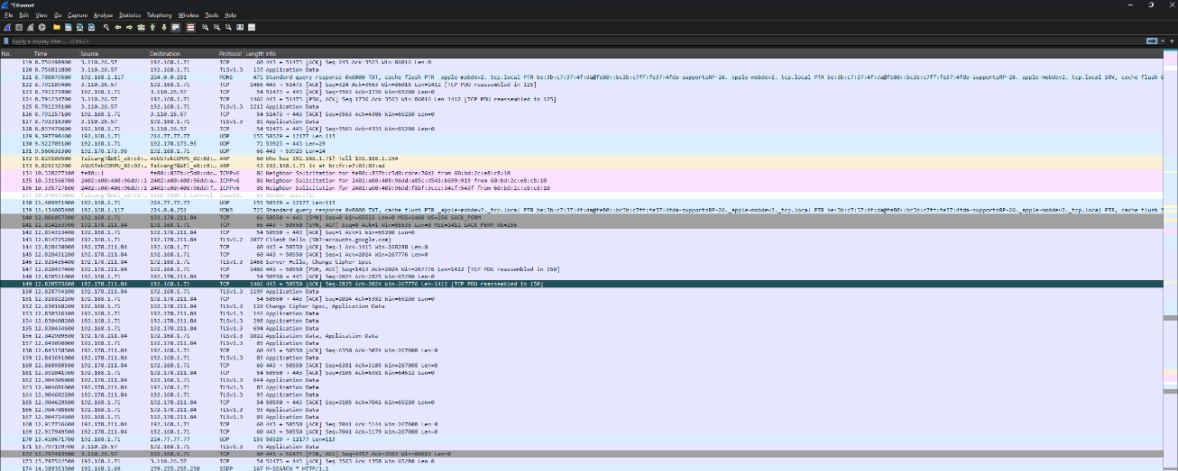
- Here’s the Network traffic I have capture during I was browsing youtube.com
Q2. Use the 'ping' command in Command Prompt or Terminal to test connectivity to www.spotify.com and www.zomato.com; record the response times and identify which site responds faster.
Ans.
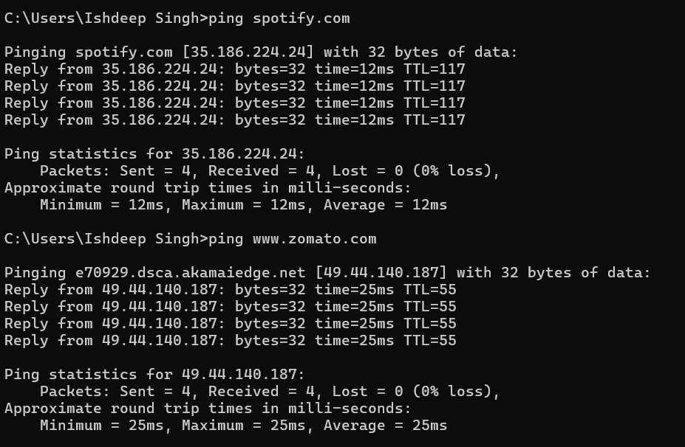
- Here’s the fast response was of spotify.com

Q3. Open Task Manager (Windows) or Activity Monitor (Mac) and list all running processes related to Chrome, WhatsApp Desktop, or any browser-based app you use; note the process name and memory usage for each.
Ans.
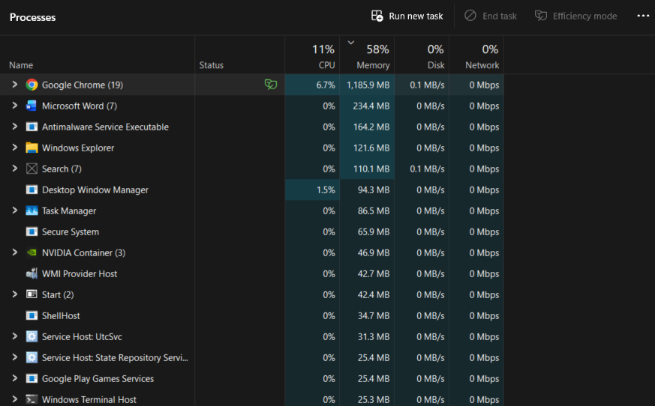
- Here’s the SS of my Task Management and the highest memory was been used by Chrome
Q4. Download and run the free version of 'Angry IP Scanner' or 'Advanced IP Scanner' to scan your local Wi-Fi network; list the IP and device name of at least 2 devices connected to your network. Hint: Make sure your firewall allows scanning, and only scan your own home/college network.
Ans.
- On my local Network, my laptop and my smartphone was been connected and their ip is
- Laptop IP – 192.168.1.71
- Smartphone IP – 192.168.1.65
Q5. Use ChatGPT or Bing AI to suggest 3 hardware tools (like cable tester, crimping tool, or multimeter) used in network troubleshooting; for each, write one line describing when you would use it.
Ans. 3 Hardware Tools for Network Troubleshooting
Hardware Tools | When You Would Use It
Cable Tester | Use it to check whether an Ethernet cable has broken wires or incorrect connections.
Crimping Tool | Use it to attach or replace RJ-45 connectors on Ethernet cables.
Multimeter | Use it to measure electrical voltage, continuity, or resistance when checking network-related power problems.

